UNIT-I
SIDDARTHA INSTITUTE OF SCIENCE AND TECHNOLOGY :: PUTTUR (AUTONOMOUS) Siddharth Nagar, Narayanavanam Road – 517583
QUESTION BANK (DESCRIPTIVE)

QUESTION BANK (DESCRIPTIVE)
Subject: Electronic Circuit Analysis (19EC0407)
Year & Sem: II-B.Tech & II-Sem
Course & Branch: B.Tech - ECE
Regulation: R19
BJT HIGH FREQUENCY MODEL ANALYSIS & MULTISTAGE AMPLIFIERS
1 | a) | Sketch the Hybrid-pi model and explain the significance of each and every component in it. |  | [L3][CO1][6M]
 | b) | Deduce the expression for Emitter diffusion capacitance of CE transistor at high frequency. |  | [L4][CO2][6M]
2 |  | Deduce the expression for the hybrid π parameters g_{m}, g_{b’e}, g_{b’c}, r_{bb’} and g_{ce}. |  | [L4][CO2][8M]
 |  | A BJT has g_{m} = 38 mhos, r_{b’e} = 5.9kΩ, h_{ie} = 6kΩ, r_{bb’} = 100Ω, C_{b’c} = 12pF,  C_{b’e}= 63pF and h_{fe} = 224 at 1 KHz. Calculate α , β cutoff frequencies and f_{T}. |  | [L3][CO4][4M]
3 | a) | At I_{c} = 1mA and V_{CE}=10V, a certain transistor data shows :C_{c} = C_{b’c} = 3pF,  h_{fe} = 200 and w_{T} = -500 M rad/sec. Calculate g_{m}, r_{b’e}, C_{e} = C_{b’e} and w_{β}. |  | [L3][CO4][6M]
 | b) | Short circuit CE current gain of a transistor is 25 at a frequency of 2MHz. If  f_{β} = 200KHz, Calculate (i) f_{T} (ii) h_{fe} (iii) Find |A_{i}| at frequency of 10MHz and 100MHz. |  | [L3][CO4][6M]
4 | With the help of necessary circuit diagrams and approximations, deduce the expression for CE short circuit current gain and derive the relation between f_{β} and f_{T}. |  |  | [L4][CO2][12M]
5 | Deduce the expression for Current gain with resistive load and discuss the variation of frequency response with R_{L}. |  |  | [L4][CO2][12M]
6 | a) |  | Explain various methods used for coupling multistage amplifiers with their frequency response. | [L2][CO1][5M]
 | b) |  | Construct the block diagram of n-stage cascaded amplifier and analyze its various parameters. | [L3][CO2][7M]
7 | With neat diagram, explain Cascode amplifier and deduce the expressions for voltage gain, overall input resistance, Overall current gain and output resistance of cascode amplifier. |  |  | [L4][CO2][12M]
8 | a) | Define Darlington Pair and list its applications. |  | [L1][CO1][4M]
 | b) | With diagram, deduce the expressions for Voltage gain, current gain, Input and ouput resistances of a Cascade amplifier. |  | [L4][CO2][8M]
9 | For the circuit shown in Fig. Calculate R_{i}, A_{i}, A_{V} and R_{o} if the h – parameters are h_{ie}=1.1kΩ, h_{fe}=50, h_{oe} = 25µA/V and h_{re} = 2.5 x 10⁻⁴. Derive the necessary expressions.  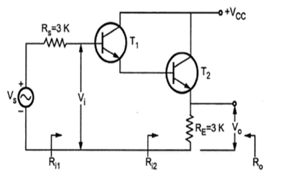 |  |  | [L3][CO4][12M]
10 | a) | Explain the effect of cascading on bandwidth in multistage amplifiers. |  | [L2][CO2][8M]
 | b) | If the overall lower and higher cutoff frequencies of a two identical amplifier cascade are 600 Hz and 18 kHz respectively, compute the values of individual cutoff frequencies of both the amplifier stages. |  | [L3][CO4][4M]
UNIT -II
FEEDBACK AMPLIFIERS

1 |  | Explain the basic concept of Feedback in amplifier with suitable block diagram. | [L2][CO1][8M]
 |  | List the characteristics of negative feedback amplifiers. | [L1][CO1][4M]
2 | a) | Explain in detail about basic Amplifiers used in Feedback amplifiers. | [L2][CO1][6M]
 | b) | Explain Feedback amplifier topologies with necessary diagram. | [L2][CO2][6M]
3 | a) | Show that bandwidth of an amplifier can be improved by using negative feedback. | [L2][CO2][8M]
 | b) | An amplifier has voltage gain with feedback of 100. If the gain without feedback changes by 20% and the gain with feedback should not vary more than 2%, determine the value of open-loop gain, A and feedback ratio, β. | [L3][CO4][4M]
4 | Deduce the expressions of Gain, input and output resistances for a Voltage Shunt feed back amplifier. |  | [L4][CO2][12M]
5 | a) | Deduce the expressions of Gain, input and output resistances for a Voltage Series feedback amplifier. | [L4][CO2][8M]
 | b) | A voltage series negative feedback amplifier has a voltage gain without feedback of A = 500, input resistance Ri = 3kΩ, output resistance R0 = 20kΩ and feedback ratio β = 0.01. Calculate the voltage gain Af, input resistance Rif, and output resistance Rof of the amplifier. | [L3][CO4][4M]
6 | a) | Show that negative feedback reduces gain of an Amplifier. | [L2][CO2][4M]
 | b) | Analyze the effect of negative feedback on Output resistance of Voltage series and Current series feedback amplifier. | [L4][CO2][8M]
7 | Determine the input and output resistances of Current Shunt feedback amplifier. |  | [L3][CO2][12M]
8 | a) | Analyze Emitter follower circuit with necessary diagram for input and output resistances with feedback. | [L4][CO3][6M]
 | b) | In the BJT emitter follower circuit shown in figure, the circuit component values are R_{s}= 600 Ω, R_{C} = 4.7 KΩ, R_{E}= 2 KΩ, h_{ie} = 5 KΩ. Calculate A_{vf}, R_{if}, R_{of} and R’_{of}. | [L3][CO4][6M]
9 | a) | An RC coupled amplifier has a mid-frequency gain of 200 and a frequency response from 100 Hz to 20 KHz. A negative feedback network with β = 0.02 is incorporated into the amplifier circuit. Estimate the new system performance. | [L5][CO4][6M]
 | b) | Explain the effect of negative feedback on input resistance for Current shunt and Voltage shunt Feedback amplifier. | [L2][CO2][6M]
10 | a) | Compare various types of feedback amplifiers. | [L4][CO2][6M]
 | b) | Compute R_{m} and R_{mf} using feedback principle for the circuit shown in figure. Assume and h_{fe} = 50 and h_{ie} = 1.1 KΩ | [L3][CO4][6M]
UNIT-III
OSCILLATORS
1 | a) | Establish the condition for oscillation with suitable diagram. | [L3][CO2][8M]
 | b) | Classify various types of oscillators. | [L2][CO1][4M]
2 | a) | Construct RC phase shift oscillator using BJT and deduce its expression for frequency of oscillations. | [L4][CO2][6M]
 | b) | Determine the frequency of oscillations when a RC phase shift oscillator has R=100 kΩ, C=0.01µF and R_{C} = 2.2 KΩ. Also find the minimum current gain needed for this purpose. | [L3][CO4][6M]
3 | a) | Determine the condition for sustained oscillations for an RC phase shift Oscillator with necessary circuit diagrams. | [L3][CO4][6M]
 | b) | Design a RC phase shift oscillator to generate 5 KHz sine wave with 20 V peak to peak amplitude. Draw the designed circuit. Assume h_{fe} = 150. | [L6][CO3][6M]
4 | a) | Explain the working principle of Wein-bridge oscillator using BJT and deduce the expression for frequency of oscillations. | [L4][CO2][8M]
 | b) | In a Wein-bridge oscillator, if the value of R is 100 KΩ, and frequency of oscillation is 10 KHz, Calculate the value of capacitor C. | [L3][CO4][4M]
5 | Analyze an LC Oscillator for a necessary equation to determine criteria for  oscillations. |  | [L4][CO2][12M]
6 | Explain Hartley oscillator using BJT and deduce the expression for its frequency of oscillations and condition for sustained oscillations.. |  | [L4][CO2][12M]
7 | a) | Explain working of Crystal oscillator and deduce the expression for frequency of oscillations. | [L4][CO2][8M]
 | b) | In a transistorized Hartley oscillator, the two inductances are 2 mH and 20 µH while the frequency is to be changed from 950 KHz to 2050 KHz. Calculate the range over which the capacitor is to be varied. | [L3][CO4][4M]
8 | a) | Draw the circuit diagram of Colpitts oscillator using BJT and deduce the expression for frequency of oscillations. | [L4][CO2][7M]
 | b) | A Colpitts oscillator is designed with C₁ = 100 pF and C₂ = 7500 pF. The inductance is variable. Determine the range of inductance values, if the frequency of oscillation is to vary between 950 KHz to 2050 KHz. | [L3][CO4][5M]
9 | Establish the condition for sustained oscillations for Hartley and Colpitts oscillator with suitable equation. |  | [L3][CO2][12M]
10 | a) | Explain in detail the concept of stability in Oscillators. | [L2][CO1][8M]
 | b) | In the Colpitts oscillator, C1 = 0.2µF and C2 = 0.02 µF. If the frequency of oscillationis 10kHz, Calculate the value of inductor. | [L3][CO4][4M]

UNIT-IV
POWER AMPLIFIERS AND TUNED AMPLIFIERS

1 | a) | With neat diagram, explain Series fed directly coupled Class A Power Amplifier and determine its maximum efficiency. | [L3][CO2][6M]
 | b) | A series fed Class A amplifier shown in the Fig, operates from dc source and applied sinusoidal input signal generates peak base current of 9mA. Determine  (i) Quiescent current I_{CQ}, (ii) Quiescent voltage V_{CEQ}, (iii) DC input power P_{DC}, (iv) AC output power P_{AC} and (v) Efficiency.  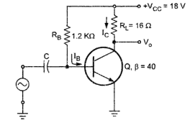 | [L3][CO4][6M]
2 | The loudspeaker of 8 Ω is connected to the secondary of the output transformer of a class A Amplifier. The quiescent collector current is 140 mA. The turns ratio of transformer is 3:1. The collector supply voltage is 10 V. If ac power delivered to the loudspeaker is 0.48 W, assuming ideal transformer, Determine (i) AC power developed across primary, (ii) RMS value of load voltage, (iii) RMS value of primary voltage, (iv) RMS value of load current, (v) RMS value of primary current, (vi) DC power input, (vii) efficiency and (viii) power dissipation. |  | [L3][CO4][12M]
3 | a) | Discuss about Transformer coupled Class A Power Amplifier with diagram and determine its Maximum efficiency. | [L3][CO2][6M]
 | b) | A Class B push pull amplifier drives a load of 16Ω, connected to the secondary of ideal transformer. The V_{cc} is 25V. If number of turns on primary is 200 and secondary is 50. Determine maximum power output, DC power input and efficiency. | [L3][CO4][6M]
4 | Explain the working principle of Push Pull Class B Power Amplifier with neat diagram and determine its maximum efficiency. |  | [L3][CO2][12M]
5 | a) | Discuss Complementary Symmetry Class B Push Pull Power Amplifier with neat diagram and determine its efficiency. | [L3][CO2][8M]
 | b) | Write notes on crossover distortion in class B power amplifier. | [L3][CO3][4M]
6 | Explain the operation of a single tuned capacitive coupled amplifier with necessary circuit diagrams and deduce the expression for its centre frequency, Quality factor, Voltage gain and bandwidth. |  | [L4][CO2][12M]
7 | Discuss about Double Tuned Amplifier with neat diagram and deduce the expression for its bandwidth. |  | [L4][CO2][12M]
8 | a) | A single tuned RF amplifier uses a transistor with an output resistance of 50 KΩ, output capacitance of 15 pF and internal resistance of next stage is 20 kΩ. The tuned circuit consists of 47 pF capacitance in parallel with series combination of 1µH inductance and 2Ω résistance. Determine resonant frequency, effective quality factor and bandwidth of the circuit. | [L3][CO3][6M]
 | b) | Explain the effect of cascading single tuned amplifiers on bandwidth. | [L2][CO2][6M]
9 | a) | With circuit diagram, describe the stagger tuning operation. Sketch necessary waveforms. | [L3][CO1][7M]
 | b) | The bandwidth of a single tuned amplifier is 20 kHz. Determine the bandwidth if three such stages are cascaded. Also calculate the bandwidth for four stages. | [L3][CO3][5M]
10 | a) | Discuss the stability considerations of a tuned amplifier. | [L2][CO2][6M]
 | b) | Compare different types of tuned amplifiers. | [L2][CO1][6M]

UNIT-V
MULTIVIBRATORS

1 | a) | With neat sketch, explain the working of a collector coupled Astable multivibrator. | [L2][CO1][8M]
 | b) | Determine the value of capacitors to be used in an Astable multivibrator to provide a train pulse 2µs wide at a repetition rate of 100 kHz, if R₁ =R₂ =20kΩ. | [L3][CO3][4M]
2 | a) | Deduce the expression for time period, T in Astable multivibrator. | [L4][CO2][8M]
 | b) | List the applications of Astable multivibrator. | [L1][CO1][4M]
3 | With neat diagram, explain the modified and Emitter Coupled Astable multivibrator. |  | [L2][CO2][12M]
4 | a) | What is a Monostable multivibrator? Explain its working with the help of waveforms. | [L2][CO2][7M]
 | b) | Deduce the expression for pulse width, T of collector coupled Monostable multivibrator. | [L4][CO2][5M]
5 | a) | Explain the operation of Emitter Coupled Monostable multivibrator. | [L2][CO1][6M]
 | b) | Calculate the component values of a Monostable multivibrator developing an output pulse of 140µs duration. Assume h_{FEmin} =20, I_{c(sat)} =6 mA, V_{CC}=6 V, V_{BB}= -1.5V. | [L4][CO3][6M]
6 | a) | Design and draw a saturated collector coupled monostable multivibrator for the following specifications: V_{CC} = 10 V, V_{BB} = -5 V, pulse duration = 12ms, I_{C(ON)}= 2 mA and two NPN transistors with minimum h_{fe} =100 and I_{CBO}=0.  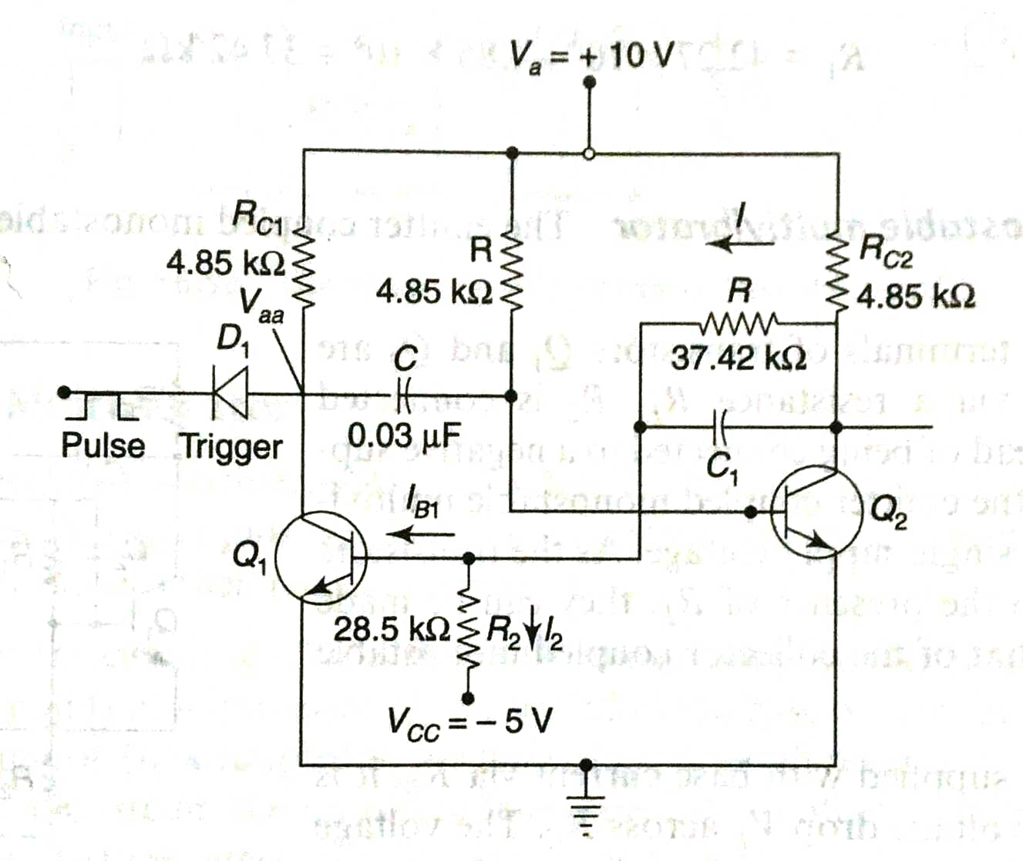 | [L6][CO3][8M]
 | b) | List the applications of Monostable multivibrator. | [L1][CO1][4M]
7 | a) | Why triggering is needed for multivibrators? Explain a triggering method for monostable multivibrator. | [L2][CO2][7M]
 | b) | Compare Astable and Monostable multivibrators. | [L4][CO1][5M]
8 | a) | Explain briefly the operation of Bistable multivibrator with neat circuit diagram. | [L2][CO2][8M]
 | b) | List the applications of Bistable multivibrator. | [L1][CO1][4M]
9 | Explain the various triggering methods for Bistable multivibrator with neat diagrams. |  | [L2][CO1][12M]
10 | a) | Design a collector coupled bistable multivibrator to operate from ± 5 V supply with I_{c(sat)} =2 mA and h_{fe}= 70.  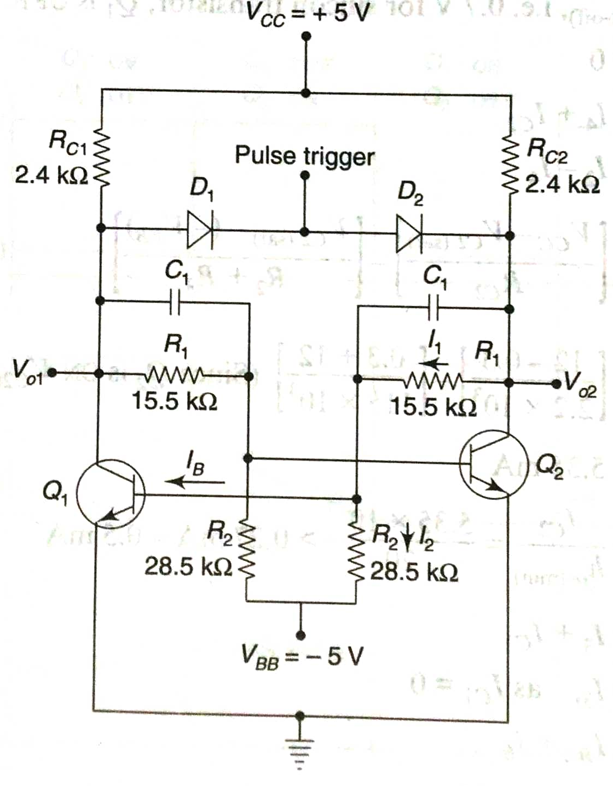 | [L6][CO4][5M]
 | b) | Calculate the stable state currents and voltages for the bistable multivibrator having V_{CC} = 12 V, V_{BB} = -12 V, R_{C1} = R_{C2} = 2.2kΩ, R₁=R₂ = 15kΩ, R₃=R₄ = 100kΩ.Assume that a transistor having a minimum h_{fe} of 20 is used.  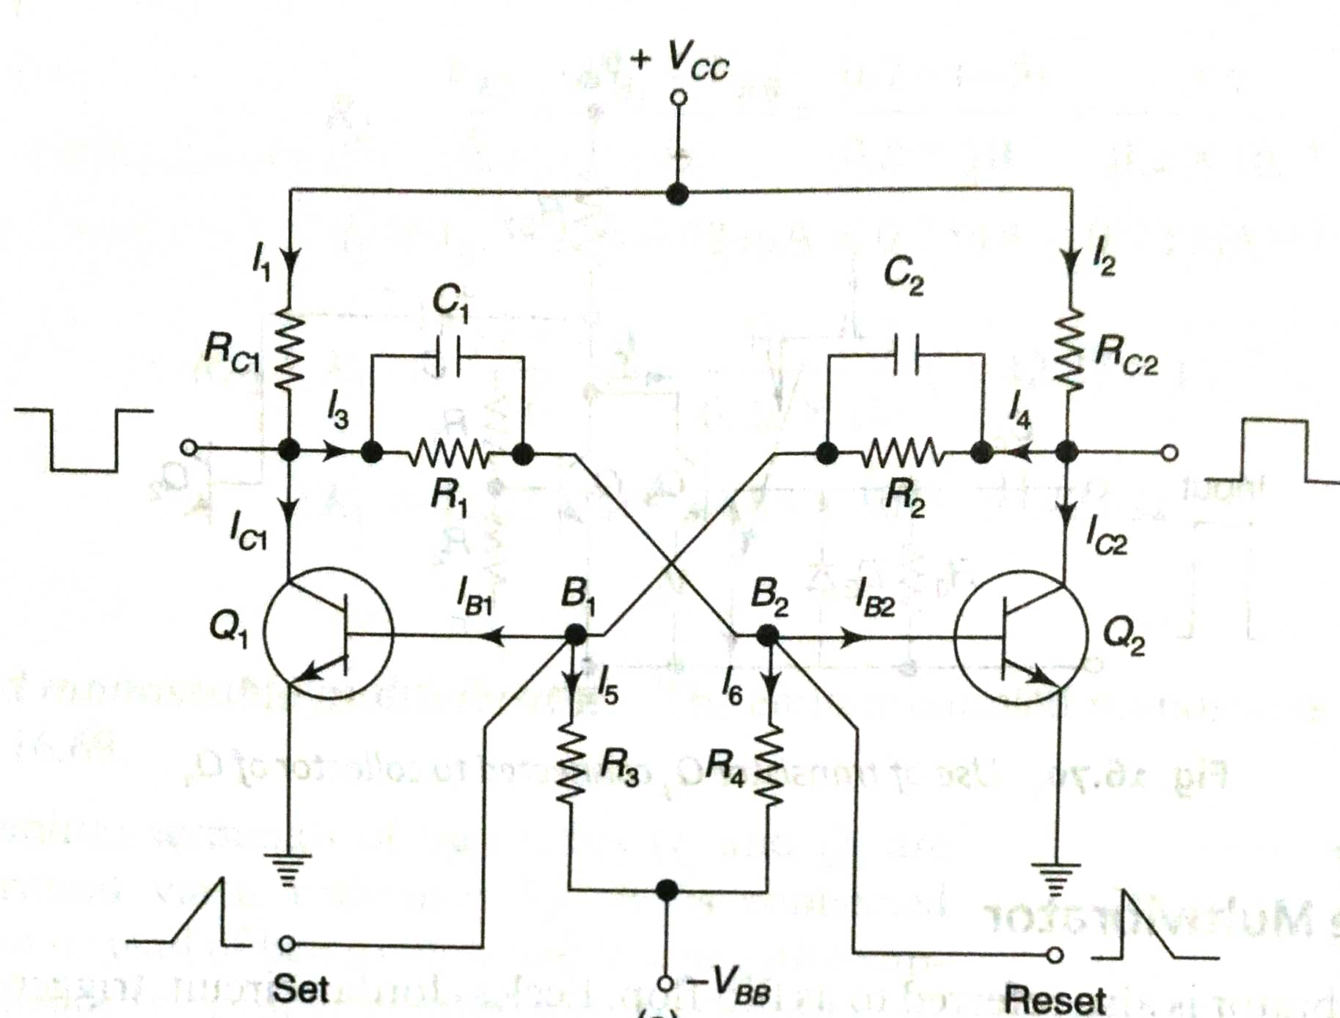 | [L4][CO4][5M]

